**UNIVERSIDAD DE LAS FUERZAS ARMADAS - ESPE**

DEPARTAMENTO DE CIENCIAS DE LA COMPUTACIÓN

**OBJECT ORIENTED PROGRAMMING**

**NRC: 9652**

**WORKSHOP #12**

DATE: 06/06/2023

DUE: 11pm

Team 1: Techware

Project's name: Panes de la Rumiñahui

Leader: Jilmar Calderon

GitHub: <https://github.com/JhoelCJ/OOP9652-Techware.git>

Inspector: Team 3 , Paul Moreno

Interview video:<https://www.youtube.com/watch?v=pNf69I-VZgA>

1. BAEZ JARAMILLO GABRIEL ALEJANDRO
2. CALDERÓN CALVA JIMAR JHOEL
3. CALVACHE BONIFAZ GABRIEL ALEXANDER
4. CASIGNIA RUIZ DIEGO ALEJANDRO

Presentation: 8/10

**Rubric**

Presentation

0.- GitHub /100

1.- Interview and Presentation 10/10 9:25 - 9:30

2.- Project definition 8/10 9:30 - 9:35

3.- Software Requirements 7.5/10 9:35 - 9:45

4.- Use Case 7/10 9:45 - 9:50

5.- Class Diagram 6/10 9:50 - 10:00

6.- Data files 9/10 10:00 - 10:20

7.- Execution 6/10

8-10.- Clean Code 17/30

TOTAL /100

**Evidence**

GitHub

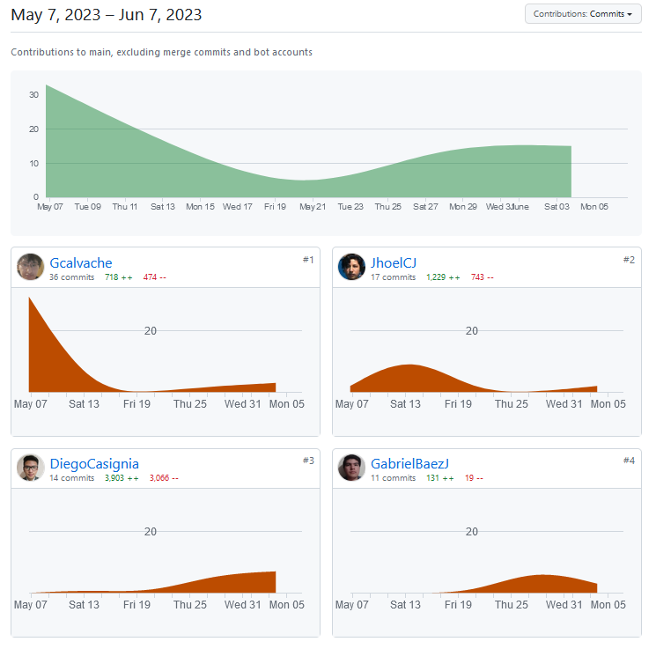

1.- Interview and Presentation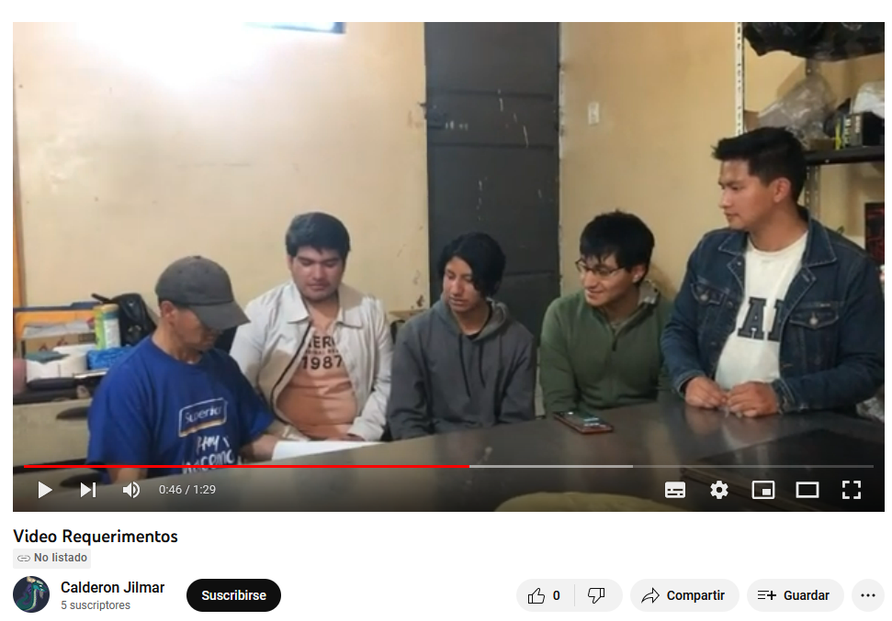

2.- Project definition

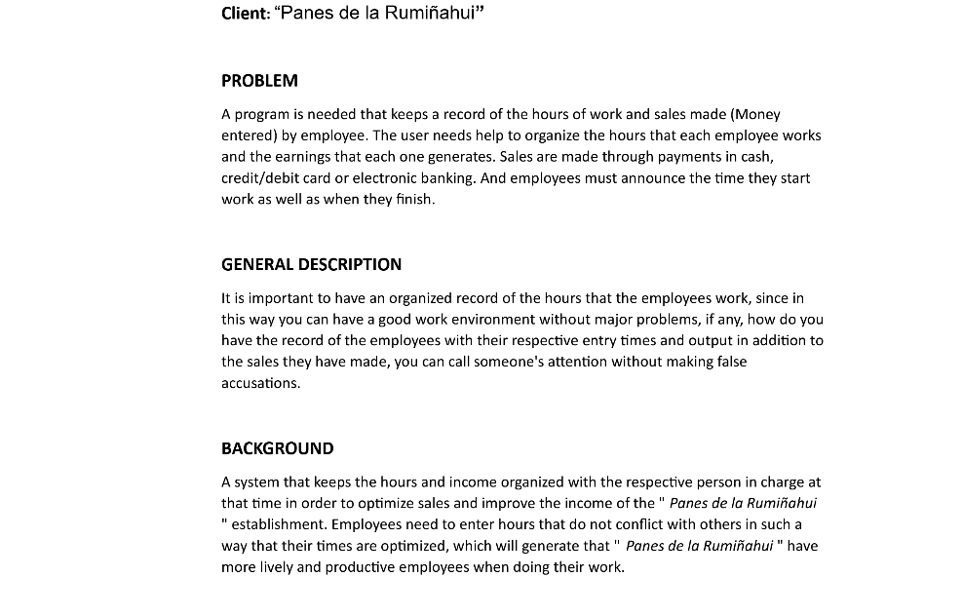

3.- Software Requirements

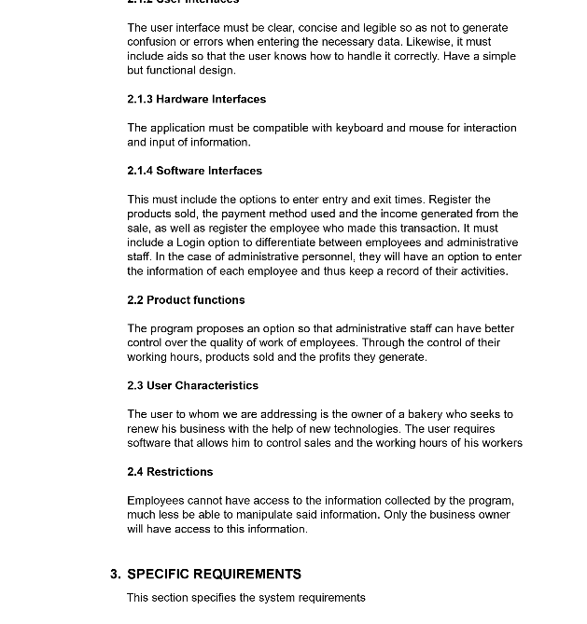

4.- Use Case

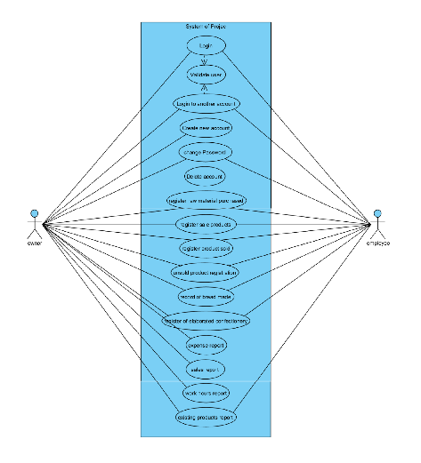

5.- Class Diagram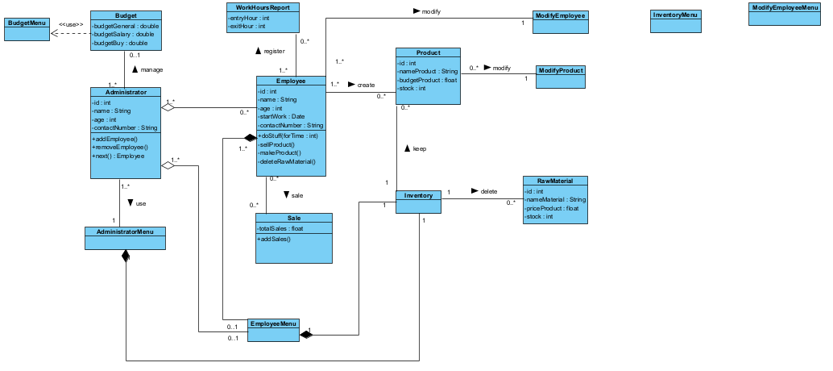

6.- Data files

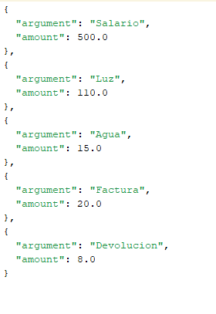

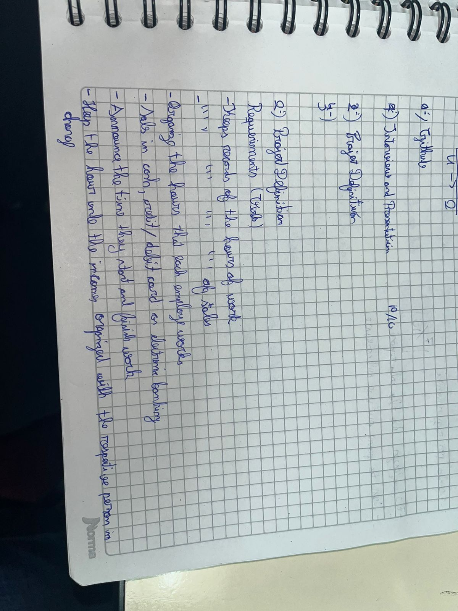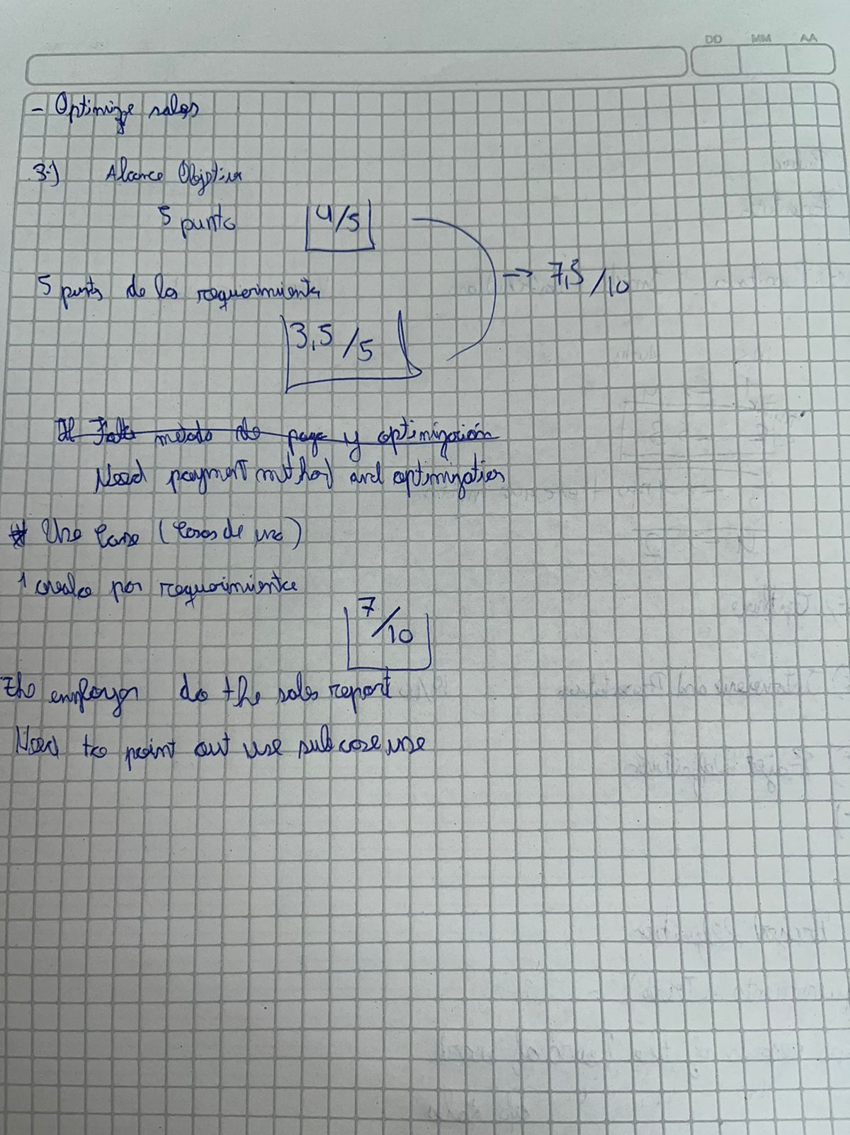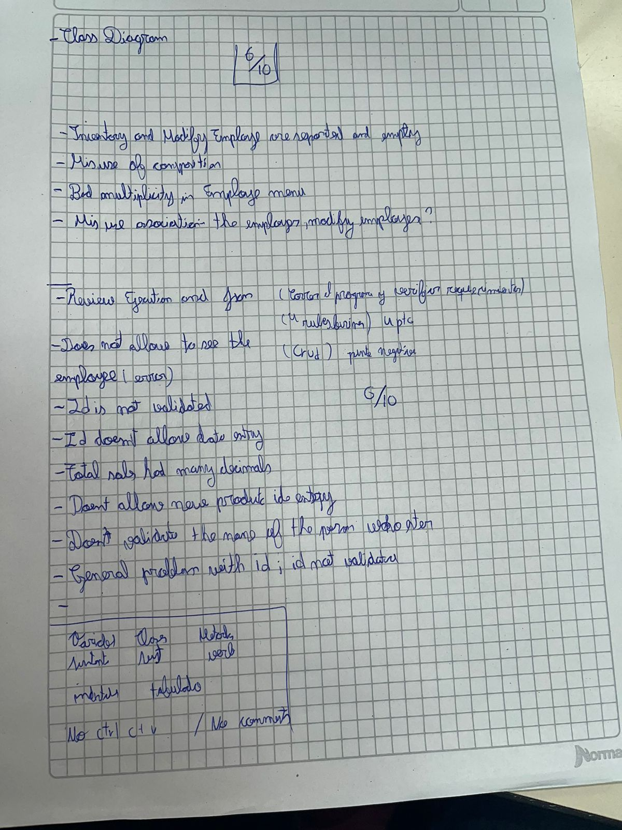

7.- Execution

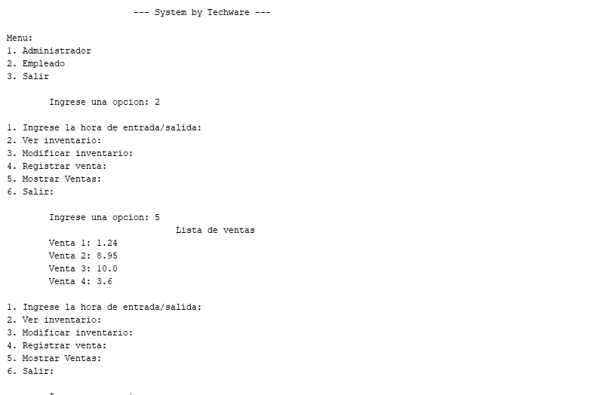

8-10.- Clean Code

-In the class”EditAdministratorData” there is an operation employee.

-In the class “EditBudgetData”there is a commented code.

-In the class “Budget” the names of operators are in UpperCamelCase.

-In the class “Inventory” the names of operators are not verbs.

-some classes are not in the correct package

-In the class” AdministratorMenu “ the name of an operator is not a verb.

-In the class” BudgetMenu “ the name of an operator is not a verb.

-In the class” EmployeeMenu “ the name of an operator is not a verb.

-In the class” InventoryMenu “ the name of an operator is not a verb.

-In the class” EmployeeMenu “ the name of an operator is not a verb.

-In the class” Sale “ the attribute is in plural..

-The class “WorkHoursReport” is in plural.

-In the class “ValidationUntil '' the boolean operator name is not in UpperCamelCase.